Ryan Riopelle

Due: March 19, 2016

**MAS 201 – Homework 4 – Sales**

**Step 1) Original Query**

SELECT cate.category_id,cust.customer_id,sum(quantity),sum(price) FROM

(SELECT category_id,sum(price) AS dollar_value FROM

sales.category NATURAL JOIN sales.product NATURAL JOIN sales.sale

GROUP BY category_id ORDER BY dollar_value DESC limit 10) AS cate,

(SELECT customer_id,sum(price) AS dollar_value FROM sales.sale

GROUP BY customer_id ORDER BY dollar_value DESC limit 10) AS cust, sales.sale s,sales.product p

WHERE p.category_id = cate.category_id and s.customer_id = cust.customer_id and s.product_id = p.product_id

GROUP BY cate.category_id,cust.customer_id ORDER BY cate.category_id

**Size**

"Sort (cost=206072.90..206073.10 rows=80 width=18)"

**Visual Representation**

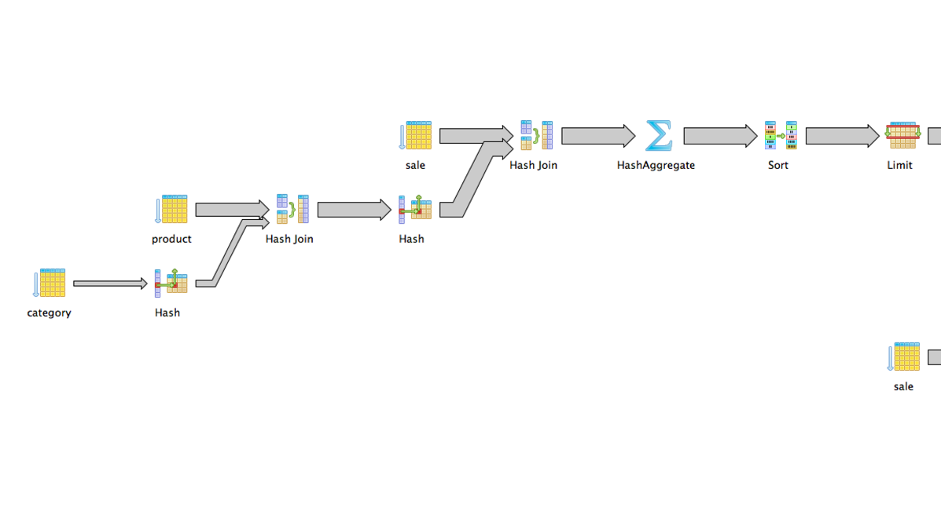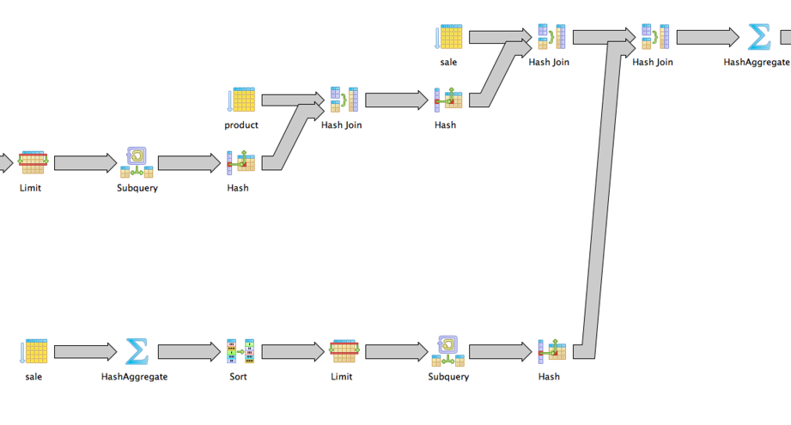

**Create Precomputed Tables**

DROP TABLE IF EXISTS sales.PRE_Category_Sale ;

create table sales.PRE_Category_Sale as

SELECT category_id,sum(price) AS dollar_value

FROM sales.category NATURAL

INNER JOIN sales.product NATURAL

INNER JOIN sales.sale

GROUP BY category_id;

DROP TABLE IF EXISTS sales.PRE_Customer_Sale;

create table sales.PRE_Customer_Sale as

SELECT customer_id,sum(price) AS dollar_value

FROM sales.sale

GROUP BY customer_id;

**--Table For Category Sales**

CREATE or replace FUNCTION sales.FN_PRE_Category_Sale() RETURNS trigger AS $FN_PRE_Category_Sale$

BEGIN

UPDATE sales.PRE_Category_Sale as pre

SET dollar_value = pre.dollar_value + NEW.price

FROM sales.product as p

WHERE pre.category_id = p.category_Id

AND p.product_id = NEW.product_id;

IF NOT FOUND THEN

--no category_id updated

INSERT INTO sales.PRE_Category_Sale (category_id, dollar_value)

SELECT p.category_id, NEW.price

FROM sales.product p

WHERE p.product_id = NEW.product_id;

END IF;

RETURN NEW;

END;

$FN_PRE_Category_Sale$ LANGUAGE plpgsql;

DROP TRIGGER IF EXISTS trigger_Sale_Category ON sales.sale ;

CREATE TRIGGER trigger_Sale_Category

BEFORE INSERT ON sales.sale

FOR EACH ROW EXECUTE PROCEDURE sales.FN_PRE_Category_Sale();

**--Table For Customer Sale**

CREATE or replace FUNCTION sales.FN_PRE_Customer_Sale() RETURNS trigger AS $FN_PRE_Customer_Sale$

BEGIN

UPDATE sales.PRE_Customer_Sale

SET dollar_value = dollar_value + NEW.price

WHERE customer_id = NEW.customer_id;

IF NOT FOUND THEN

--no category_id updated

INSERT INTO sales.PRE_Customer_Sale (customer_id, dollar_value)

SELECT NEW.customer_id, NEW.price;

END IF;

RETURN NEW;

END;

$FN_PRE_Customer_Sale$ LANGUAGE plpgsql;

DROP TRIGGER IF EXISTS trigger_Sale_Customer ON sales.sale ;

CREATE TRIGGER trigger_Sale_Customer

BEFORE INSERT ON sales.sale

FOR EACH ROW EXECUTE PROCEDURE sales.FN_PRE_Customer_Sale();

**"Sort (cost=51197.86..51198.11 rows=100 width=18)"**

**MAS 201 – Homework 4 – Cats**

**Step1) Original Query from Homework 2 – Using ID = 95572**

*WITH WeightOfUsers*

*AS (*

*SELECT ly.user_id*

*,LOG(1 + COUNT(*)) AS weight*

*FROM cats.LIKE lx*

*,cats.LIKE ly*

*WHERE lx.user_id = 1*

*AND lx.video_id = ly.video_id*

*GROUP BY ly.user_id*

*)*

*SELECT l.video_id*

*,SUM(w.weight) AS sum_weight*

*FROM cats.LIKE l*

*,WeightOfUsers w*

*WHERE l.user_id = w.user_id*

*GROUP BY l.video_id*

*ORDER BY sum_weight DESC LIMIT 10*

Result of Original Query Cost with ID=95572:

"Limit (cost=228117.99..228118.02 rows=10 width=12)"



**Step 2) Create the pre computed table**

*--Table Precomputation*

*DROP TABLE IF EXISTS cats.PRE_WeightOfUsers;*

*CREATE TABLE cats.PRE_WeightOfUsers AS*

*SELECT lx.user_id AS x_user_id,*

*ly.user_id AS y_user_id,*

*COUNT(*) AS weight*

*FROM cats.LIKE lx*

*,cats.LIKE ly*

*WHERE lx.video_id = ly.video_id*

*GROUP BY lx.user_id, ly.user_id;*

**Step 3) Setup trigger operations**

**--Triggers**

*CREATE or replace FUNCTION cats.FN_PRE_WeightOfUsers() RETURNS trigger AS $FN_PRE_WeightOfUsers$*

*BEGIN CREATE TEMP TABLE users as SELECT user_id FROM cats.LIKE WHERE video_id = NEW.video_id*

*UNION SELECT NEW.user_id; WITH U AS (SELECT user_id FROM users)*

*UPDATE CATS.PRE_WeightOfUsers SET weight = weight + 1 WHERE (x_user_id IN (SELECT user_id*

*FROM U) AND y_user_id = NEW.user_id)*

*OR (y_user_id IN (SELECT user_id FROM U) AND x_user_id = NEW.user_id);*

*WITH U AS (SELECT user_id FROM users), I as (SELECT u.user_id as x_user_id, NEW.user_id as y_user_id*

*FROM U UNION SELECT NEW.user_id as x_user_id , u.user_id as y_user_id*

*FROM U UNION SELECT NEW.user_id as x_user_id, NEW.user_id as y_user_id), X as (*

*SELECT * FROM I EXCEPT SELECT x_user_id,y_user_id FROM Cats.PRE_WeightOfUsers) INSERT INTO cats.PRE_WeightOfUsers*

*(x_user_id,y_user_id,weight)SELECT *,1 FROM X; RETURN NEW;END;*

*$FN_PRE_WeightOfUsers$ LANGUAGE plpgsql;*

*DROP TRIGGER IF EXISTS trigger_LIKE ON CATS.LIKE ;*

*CREATE TRIGGER trigger_LIKE*

*BEFORE INSERT ON CATS.LIKE*

*FOR EACH ROW EXECUTE PROCEDURE cats.FN_PRE_WeightOfUsers();*

**Step 4) Implement The Add Row Update Queries**

*create or replace function insertValuesSales(num integer) returns void as $$*

*DECLARE*

*sale_val integer;*

*cust_val integer;*

*product_val integer;*

*quant_val integer;*

*price_val integer;*

*i integer;*

*BEGIN*

*i := 1;*

*WHILE i <= num LOOP*

*execute 'select max(sale_id) from sales.sale' into sale_val;*

*execute 'SELECT trunc(random() * ((select max(customer_id) from sales.customer)-1) + 1)' into cust_val;*

*execute 'SELECT trunc(random() * ((select max(product_id) from sales.product)-1) + 1)' into product_val;*

*quant_val := trunc(random() * 14 + 1);*

*price_val := random() * 695 + 5;*

*insert into sales.sale (sale_id,customer_id,product_id,quantity,price) values (sale_val+1,cust_val,product_val,quant_val,price_val);*

*i := i + 1;*

*END LOOP;*

*END ;$$ LANGUAGE plpgsql*

**Step 5) Check New Query That Utilizes The Triggers and Pre-computed Table**

*WITH WeightOfUsers AS (SELECT y_user_Id AS user_id,log(sum(1 + weight)) AS weight*

*FROM cats.PRE_WeightOfUsers WHERE x_user_id = 49976 GROUP BY y_user_id)*

*SELECT l.video_id,SUM(w.weight) AS sum_weight FROM cats.LIKE l, WeightOfUsers w*

*WHERE l.user_id = w.user_id GROUP BY l.video_id ORDER BY sum_weight DESC LIMIT 10*

*Cost of the new query with User_Id = 95572 Selected*

*"Limit (cost=20793.31..20793.33 rows=10 width=36)"*

**

**Step 6) Create indexes**

*CREATE INDEX pre_weight_of_users_x*

*ON cats.pre_weightofusers*

*USING btree*

*(x_user_id);*

*CREATE INDEX pre_weight_of_users_x_y_id_and_weight*

*ON cats.pre_weightofusers*

*USING btree*

*(x_user_id, y_user_id, weight);*

*CREATE INDEX video_id_user_id_idx*

*ON cats."like"*

*USING btree*

*(video_id, user_id);*

**Step 7) Check New Query With ID’s Added In**

*WITH WeightOfUsers AS (SELECT y_user_Id AS user_id,log(sum(1 + weight)) AS weight*

*FROM cats.PRE_WeightOfUsers WHERE x_user_id = 49976 GROUP BY y_user_id)*

*SELECT l.video_id,SUM(w.weight) AS sum_weight FROM cats.LIKE l, WeightOfUsers w*

*WHERE l.user_id = w.user_id GROUP BY l.video_id ORDER BY sum_weight DESC LIMIT 10*

*Cost of the new query with User_Id = 95572 Selected*

* *"Limit (cost=18720.28..18720.30 rows=10 width=36)"*
* Note: this is much faster than without the ID’s and without the precomputed table

**

**Step 7) Cost Breakdown of New Query with ID’s Added In**

**Create Temp Table**

*"HashAggregate (cost=1363.68..1367.60 rows=392 width=4)"*

*CREATE TEMP TABLE users as*

*SELECT user_id FROM cats.LIKE WHERE video_id = 25*

*UNION*

*SELECT 25;*

**Update Temp Table**

"Update on pre_weightofusers (cost=142.00..4231.63 rows=452 width=22)"

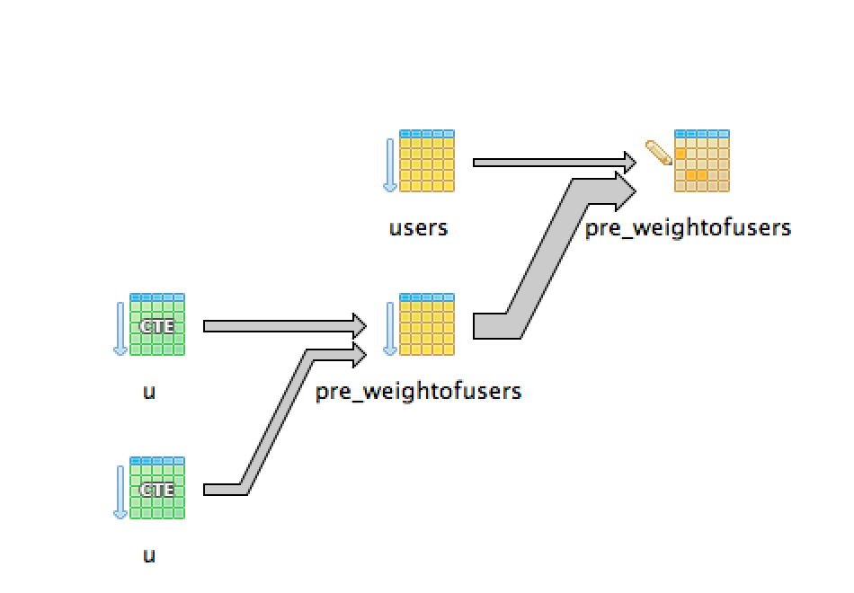

*WITH U AS (SELECT user_id FROM users)*

*UPDATE CATS.PRE_WeightOfUsers SET weight = weight + 1 WHERE (x_user_id IN (SELECT user_id*

*FROM U) AND y_user_id = 95572)*

*OR (y_user_id IN (SELECT user_id FROM U) AND x_user_id = 95572);*

**Insert Temp Table**

*"Insert on pre_weightofusers (cost=5311.19..5320.81 rows=481 width=8) (actual time=145.992..145.992 rows=0 loops=1)"*

*WITH*

*U AS (*

*SELECT user_id FROM users),*

*I as (*

*SELECT u.user_id as x_user_id, NEW.user_id as y_user_id*

*FROM U UNION SELECT NEW.user_id as x_user_id , u.user_id as y_user_id*

*FROM U UNION SELECT NEW.user_id as x_user_id, NEW.user_id as y_user_id),*

*X as (*

*SELECT * FROM I EXCEPT SELECT x_user_id,y_user_id FROM Cats.PRE_WeightOfUsers)*

*INSERT INTO cats.PRE_WeightOfUsers*

*(x_user_id,y_user_id,weight)SELECT *,1*

*FROM X; RETURN NEW;END;*

*$FN_PRE_WeightOfUsers$ LANGUAGE plpgsql;*

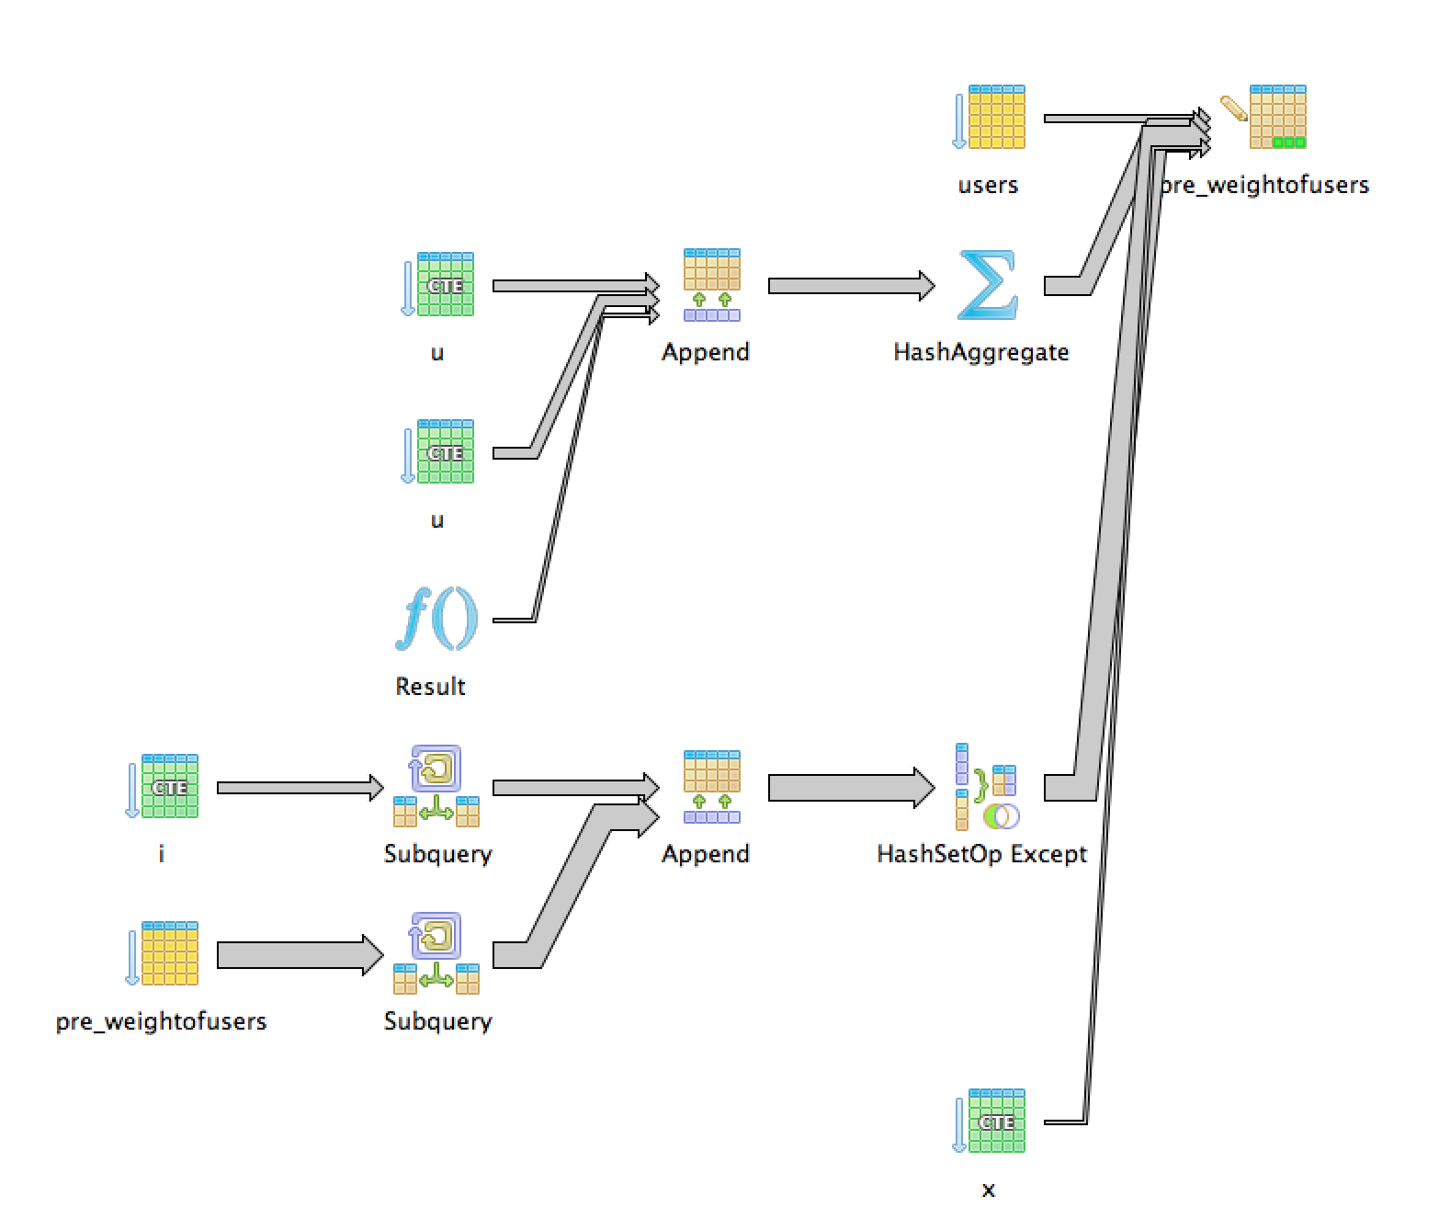

|  |  |  |
| --- | --- | --- |
| *Cost of Each Portion of The Trigger Function* | | |
| *Create Temp* | *Update* | *Insert Table* |
| *cost=1363.68* | cost=142.00 | *cost=5311.19* |

***Total Cost=1363+142+5311=6816***

***Conclusion:***

The trigger function total cost across the create, update, and insert tables is 6816. This total is significantly less than the cost of the original query of 206072.9 by a large amount. In order to calculate frequency of updates that would work we calculate it by the difference divided by the size of the maintenance.This value is (206072-6816)/6816= 29. This number shows the relative important and available frequency of the update on average.